Antonious Girgis Shawkiy 20182612

Alaa Gamal Abdelhaleem 20184859

Doaa Saber Almetwally 20182153

Remon William Makram 20182074

Mariam Fathy Wardkhan 20184294

MOTOR SPEED CONTROL

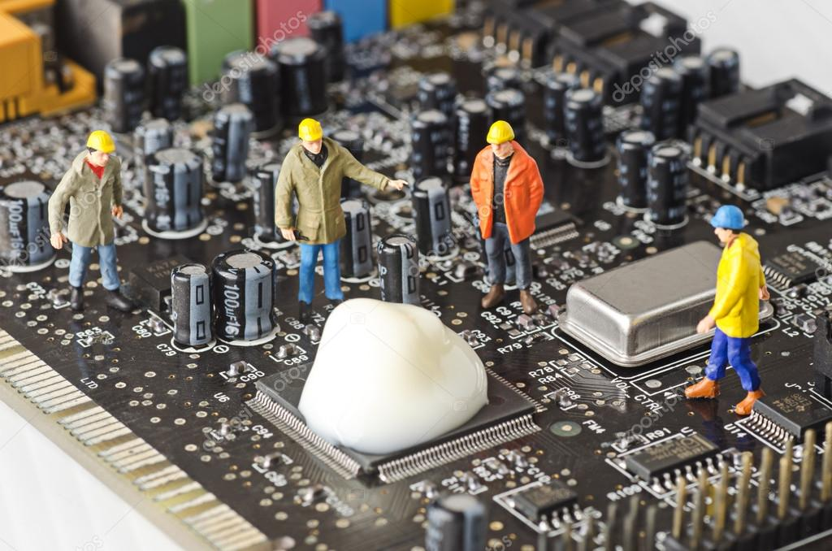

Contents

Introduction of motor speed control: 2

Functions of motor speed control: 2

circuit diagram: 3

Components description: 4

Model calculations: 7

Capture image of project: 8

Obstacles: 9

Disadvantages the motor speed control: 9

Future scope of motor speed control: 9

References: 10

# Introduction of motor speed control:

Speed control means intentional change of drive speed to a value required for performing the specific work process. This concept of speed control or adjustment should not be taken to include the natural change in speed which occurs due to change in the load on the shaft.

# Functions of motor speed control:

* Robotic controls
* 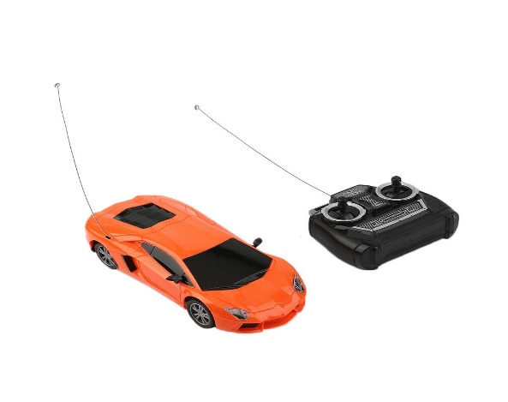Swing machines
* Electronic bikes
* DC operated drill machines
* Mobile air condition fans
* Toys
* Electronic doors controllers
* Electronic chairs

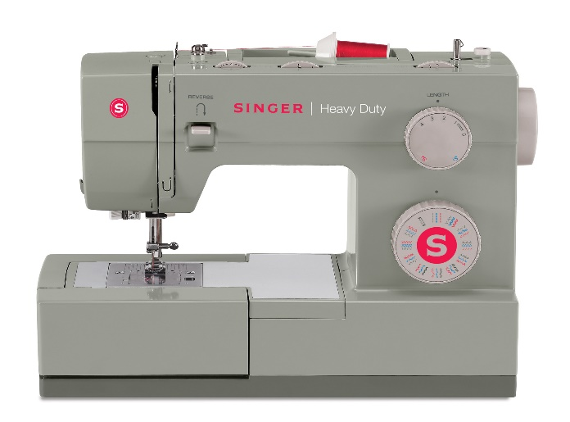

# circuit diagram:

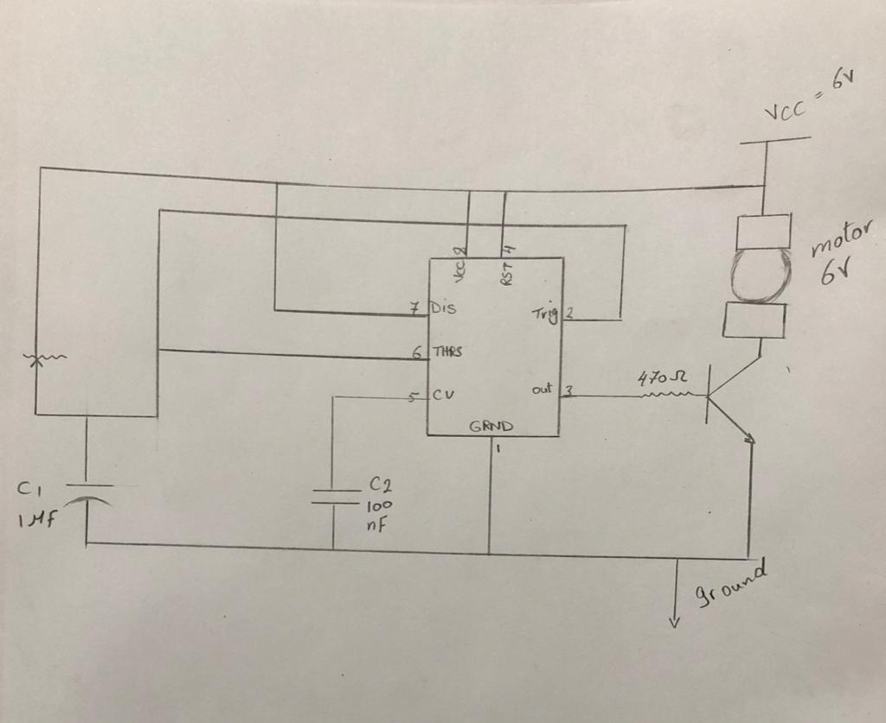

# Components description:

1. Lm 555 timer:

The 555 timer IC is an integrated circuit (chip) used in a variety of timer, pulse generation, and oscillator applications. The 555 can be used to provide time delays, as an oscillator, and as a flip-flop element.

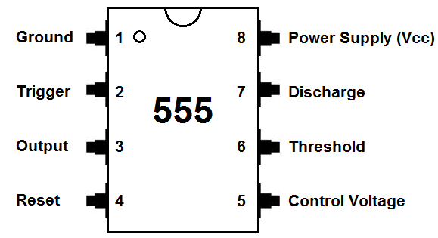

1. Resistance:

Resistance is the opposition that a substance offers to the flow of electric current. The standard unit of resistance is the ohm.

* We used two types of resistances:
* Resistance 470 ohm.
* Resistance 1000 ohm.

1. Transistor:

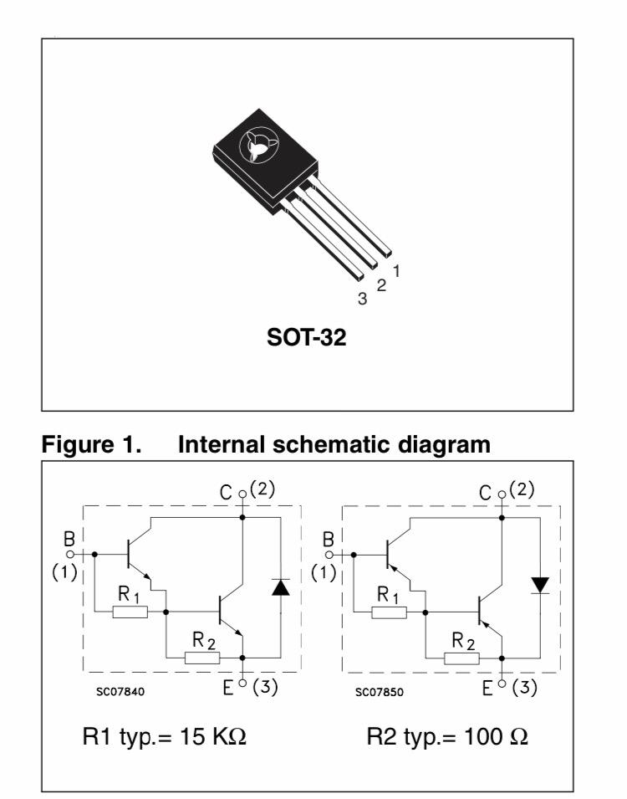

A transistor is a device that regulates current or voltage flow and acts as a switch or gate for electronic signals. Transistors consist of three layers of a semiconductor material, each capable of carrying a current.

1. Dc Motor:

A direct current or DC motor converts electrical energy into mechanical energy.

We used DC motor 6 volt

1. variable resistance:

It is an electronic component. It is applied in an electronic circuit for adjusting circuit resistance to control voltage or current of that circuit or part of that circuit. The electrical resistance is varied by sliding a wiper contact along a resistance track. Sometimes the resistance is adjusted at preset value as required at the time of circuit building by adjusting screw attached to it and sometimes resistance can be adjusted as when required by controlling knob connected to it.

* We used variable resistances: 5kΩ.

1. Capacitor:

A capacitor is a passive electronic component that stores energy in the form of an electrostatic field. In its simplest form, a capacitor consists of two conducting plates separated by an insulating material called the dielectric. The capacitance is directly proportional to the surface areas of the plates and is inversely proportional to the separation between the plates.

* We used two types of capacitors:
* capacitor 100 µF.
* capacitor 1 µF.

1. Battery 6 volt

# Model calculations:

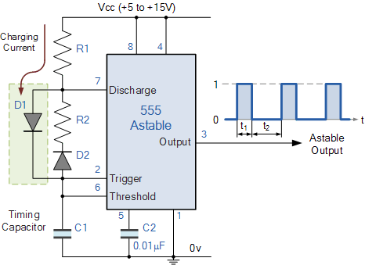

Time high (T1)   = 0.693 × (R1+R2) × C1

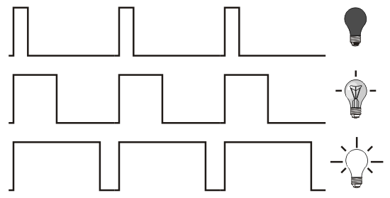

* 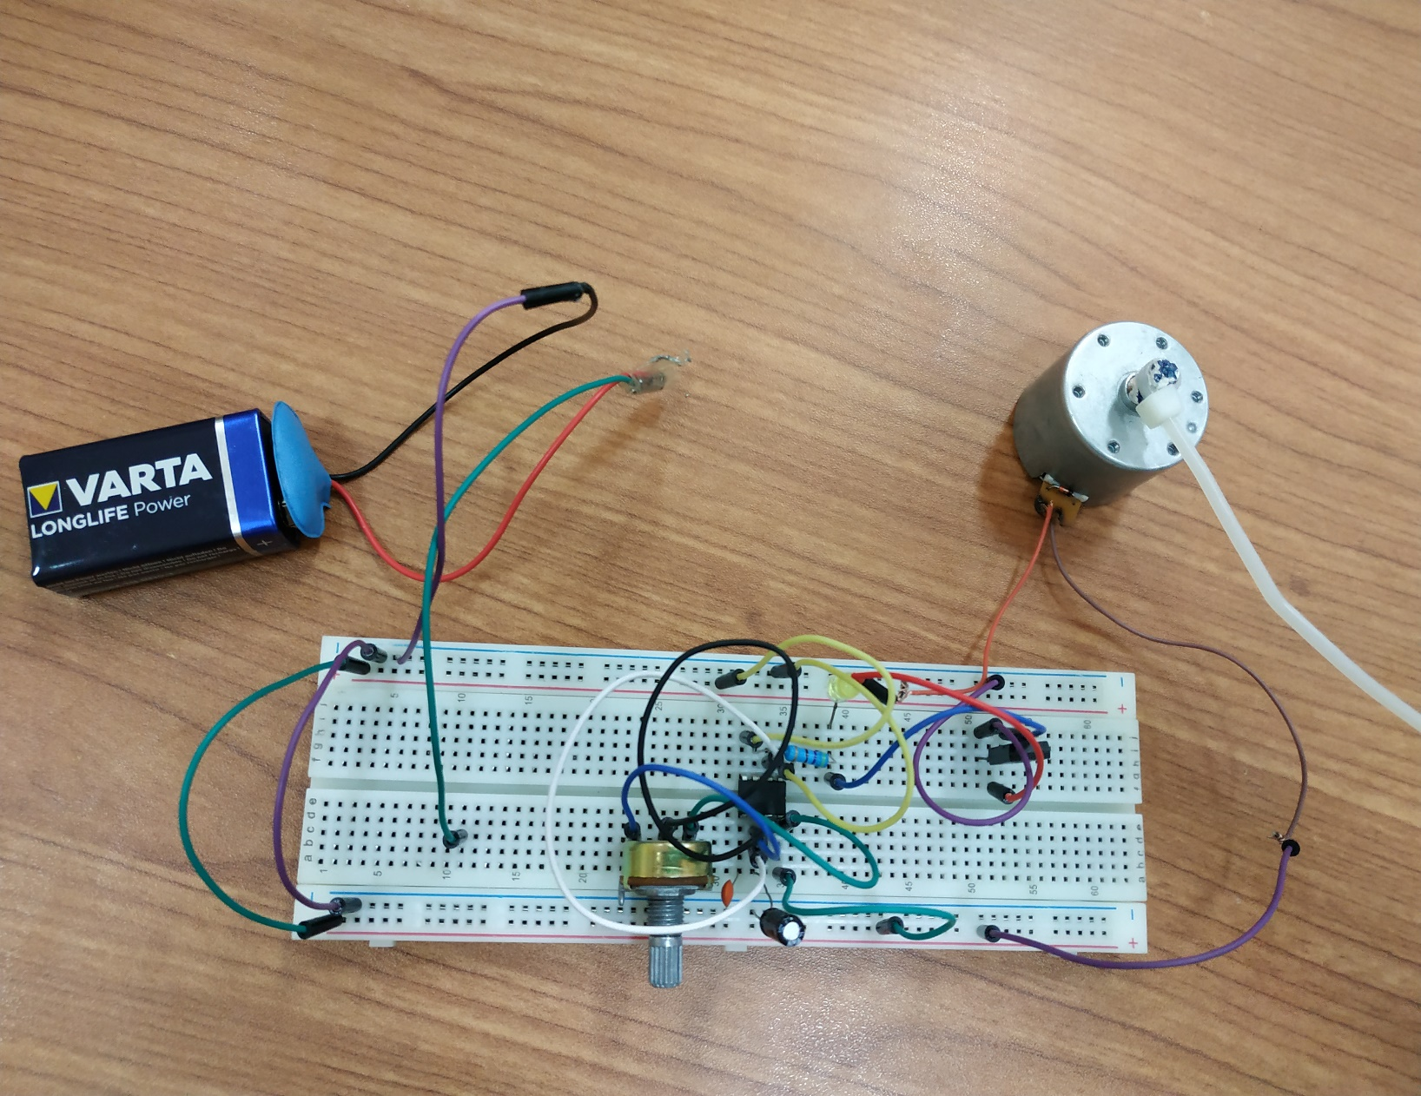Capture image of project:

# Obstacles:

* We can’t understand the circuit, so we simplify the circuits by dividing circuit into two parts to connect wire easily
* We faced that the two diodes in the circuit diagram was in the same direction, so we removed them by returning to the instructor
* We replaced the capacitor 1 nF with electrolytic capacitor 1µF to control the speed of the motor clearly
* We connected a bridge between the two parts of the breadboard to expand the range between positive and the negative
* We can’t connect the rheostat until we read the data sheet and the LM 555 timer formula

# Disadvantages the motor speed control:

* Losses in DC Machine :

As we know “Energy neither can be created, nor it can be destroyed, it can only be transferred from one form to another”. In DC machine, mechanical energy is converted into the electrical energy. During this process, the total input power is not transformed into output power. Some part of input power gets wasted in various forms. The form of this loss may vary from machine to machine. These losses give in rise in temperature of machine and reduce the efficiency of the machine. In DC Machine, there are broadly four main categories of energy loss.

# Future scope of motor speed control:

This project can be upgraded using some advanced technique We can add a new motor with connecting wire and connect it with the transistor and connect them with led When we connect the new motor with the old one and the beginning of connecting wire of new motor with the fourth leg Of LM 555 and the end of the wire in any separated point connected with new transistor that will generate electricity and we will test this by led we will see that the led will bright

# References:

* <https://whatis.techtarget.com/glossary/Electronics>
* <https://www.onsemi.com/pub/Collateral/BD675-D.PDF>
* <https://www.electronics-tutorials.ws/waveforms/555_oscillator.html>
* <http://www.apogeeweb.net/article/72.html>
* <https://www.academia.edu/30727855/Speed_control_of_DC_motor_by_using_PWM_technique_project_report>
* Gopal K Dubey “Fundamentals of Electric Drives” Narosa Publishing House
* New Delhi, 1989.
* Muhammad H. Rashid, ‘‘Power Electronics Circuits, Devices, and Applications,”
* Prentice Hall, 3rd edition, 2003.
* Kumara MKSC, Dayananda PRD, Gunatillaka MDPR, Jayawickrama SS, “PC based
* speed controlling of a dc motor”, A fmal year report University of Moratuwa
* Illiniaus USA, 2001102.
* J Nicolai and T Castagnet , “A Flexible Micro controller Based Chopper Driving a
* Permanent Magnet DC Motor”, The European Power Electronics
* Application. 1993